Control Charts

Purpose/Definition: A control chart is a visual representation of process consistency intended to highlight special cause (assignable unique variation) from common cause (normal and expected variation), and whether or not the process is performing predictably. Control charts may be used in Measure, Analyze, Improve, or Control Phases.

Overview: Control charts plot data in time order, with a centerline indicating the mean and control limits within 3 standard deviations of the mean. These are called the upper control limits (UCL) and lower control limits). Control limits define the area three standard deviations on either side of the mean and are synonymous with specification limits (defined by the customer).

There are several different control chart types that can be used, depending on the type of data to be analyzed. If you are unfamiliar with control charts or what control chart to use, please contact the Quality & Safety office personnel:

Control Chart Example:
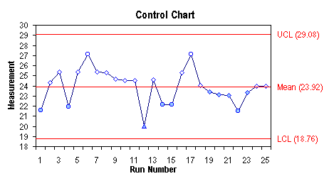

Assessing Special Causes:
- Any point outside the UCL or LCL
- 7 or more points above or below the center line
- 7 or more points in once direction
- 2 out of 3 consecutive points beyond 2 standard deviations on the same side
- 4 our of 5 consecutive points beyond 1 standard deviation on the same side
- 15 consecutive points within 1 standard deviation above or below the mean
- 8 consecutive points beyond 1 standard deviations on either side of the mean

Confirmation of one or more of the above tests may signal a special cause in our performance (something that is not part of the consistent/predictable process). This gives us reason to act, to investigate how the time period differs from other time periods. When the reason for, or location of the difference is determined, we try to replicate the behaviors or processes in a desirable special cause or remove the behaviors or processes in an undesirable special cause.

