Histogram

Definition/Purpose: a histogram is a vertical bar chart of a frequency distribution of data. It is used as a check on a specific process parameter to determine where the greatest amount of variation occurs in the process, or to determine if process specifications are exceeded. The histogram becomes an effective, practical working tool in the Measure phase.

Interpretation:
- Is the process performing within specification limits?
- Does the process seem to exhibit wide variation?
- If action needs to be taken on the process, what action is appropriate?
The answer to these three questions lies in analyzing 3 characteristics of the histogram:
- How well is the histogram centered? The centering of the data provides information on the process aim about some mean or nominal value.
- How wide is the histogram? Looking at histogram width defines the variability of the process about the aim.
- What is the shape of the histogram? Remember that the data is expected to form a normal or bell-shaped curve. Any significant change or anomaly usually indicates that there is something going on in the process, which is causing the quality problem.
For the histogram to be representative of the true process behavior, as a general rule, at least fifty (50) samples should be measured.

Examples of Typical Distributions:
- STANDARD/NORMAL-depicted by a bell-shaped curve
  - most frequent measurement appears as center of distribution
  - Less frequent measurements taper gradually at both ends of distribution
  - Indicates that a process is running normally (only common causes are present)
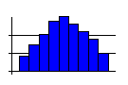
- BI-MODAL-distribution appears to have two peaks. You will need to distinguish between the two processes to get a clear view of what is really happening in either individual process
  - May indicate that data from more than one process are mixed together
  - Materials may come from two separate vendors
  - Samples may have come from two separate machines
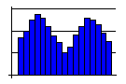
- CLIFF-LIKE/TRUNCATED - peak at or near the edge while trailing gently off to the other side
  - Often means that part of the distribution has been removed through screening, 100% inspection, or review
  - These efforts are usually costly and make good candidates for improvement efforts
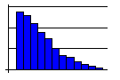
- SKEWED - appears as an uneven curve, with one tail longer than the other
  - Values seem to taper to one side.
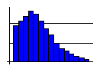
5. PLATEAU-LIKE - often means the process is ill-defined to those doing the work, which leaves everyone on their own.
a. Since everyone handles the process differently, there are many different measurements with none standing out.
b. The solution here is to clearly define an efficient process.
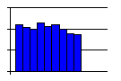
6. OUTLIERS – bars that are removed from the others by at least the width of one bar
a. May indicate a separate process is included, but one that doesn't happen all the time.
b. May indicate special causes of variation are present in the process and should be investigated, though if the process is in control before the histogram is made, this latter option is unlikely.
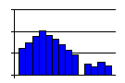
7. SAW-TOOTHED- appears as an alternating jagged pattern
- Often indicates a measuring problem

